# Lesson 3 – Georeferencing and Modifying Features

## GENERAL INFORMATION ON COORDINATE SYSTEMS AND PROJECTIONS

### WGS 84

When you define accurate positions of features in a GIS you need a reference coordinate system. The OpenStreetMap data used for these lessons is defined in the World Geodetic System (WGS84). The WGS 84 coordinates are approximated on to an ellipsoid using degrees of latitude and longitude. WGS 84 works well for modelling spatial features (such as GNSS points), though it is not good for displaying on a flat screen. You can see the distortions in your dataset. The map view looks squeezed and distorted into east-west. Furthermore, the angles are not preserved. Orthogonal crossroads on our map view are distorted, too. This is because Esri uses the very simple equi-rectangular projection as default for WGS 84. The equi-rectangular projection preserves distances along the meridians, but shows heavy spatial distortions elsewhere.

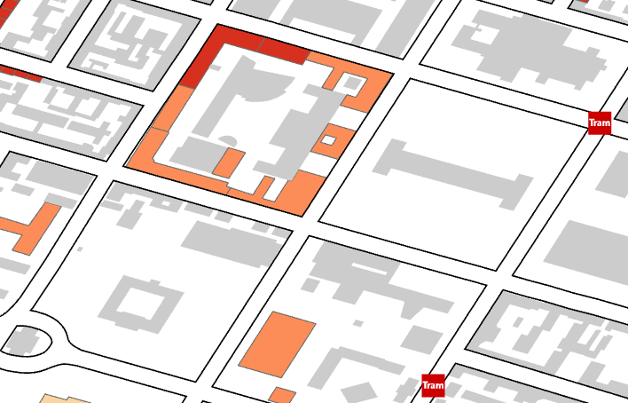

* The task is to draw the map data into a local projection in order to minimise distortions.

### Flattening the Earth

It’s impossible to flatten the Earth without distorting it in some fashion. Consider an orange peel: if you want to try and lay it flat, you have to stretch it, squash it, and tear it. Likewise, with the Earth - if we want to make a map, we need to distort the Earth’s surface to flatten it. The good news is that map projections allow us to distort systematically; we know exactly how things are being stretched or squashed at any given point. We have many different map projections because each has different patterns of distortion - there is more than one way to flatten an orange peel. Some projections can even preserve certain features of the Earth without distorting them, though they can’t preserve everything.

### The Distortion Problem

Because the earth is round and maps are flat, getting information from a curved surface to a flat one involves a mathematical formula called a map projection, or simply a projection. This process of flattening the earth will cause distortions in one or more of the following spatial properties:

* Distance
* Area
* Shape
* Direction

No projection can preserve all these properties. As a result, all flat maps are distorted to some degree. Fortunately, you can choose from many different map projections. Each is distinguished by its suitability for representing a particular portion and amount of the earth’s surface and by its ability to preserve distance, area, shape, or direction. Some map projections minimize distortion in one property at the expense of another, while others strive to balance the overall distortion. As a mapmaker, you can decide which properties are most important and choose a projection that suits your needs.

### Map Projections

Map projections can be generally classified according to what spatial attribute they preserve:

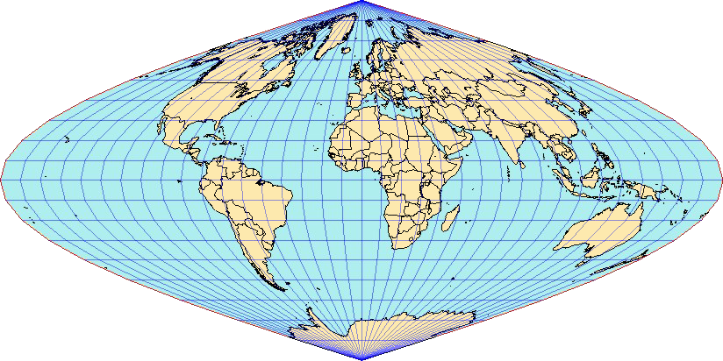**Equal Area projections** preserve area. Many thematic maps use an equal area projection. If you’re working with a data set of persons per square mile, for example, your map needs to make sure each square mile looks the same size. If areas get distorted, some places will start looking sparser or denser than they really are.

**Conformal projections** preserve local angles. Therefore, they don’t distort the local shape. Conformal projections are useful for navigational charts and general-purpose reference mapping, where we want to keep places looking recognizable and familiar. Shape is preserved for small areas, but the shape of a large area such as a continent will be significantly distorted. The Lambert Conformal Conic and Mercator projections are common conformal projections.

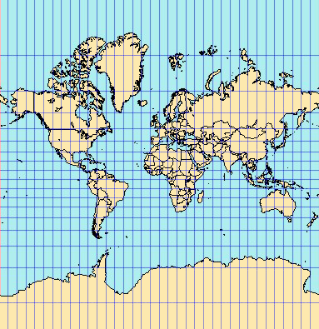

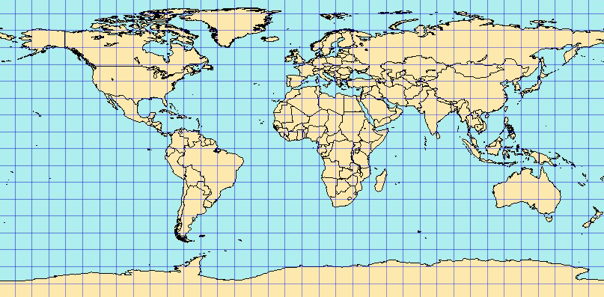**Equidistant projections** preserve distances, but no projection can preserve distances from all points to all other points. Instead, distance can be held true from one point (or a few points) to all other points or along all meridians or parallels. If you’d like to show, visually, how far one thing is from another, you’re going to need to preserve distance. Sometimes airports use these to show the cities they fly to projection.

**Azimuthal projections** preserve direction from one point to all other points. This quality can be combined with equal area, conformal, and equidistant projections, as in the Lambert Equal Area Azimuthal and the Azimuthal Equidistant projections.

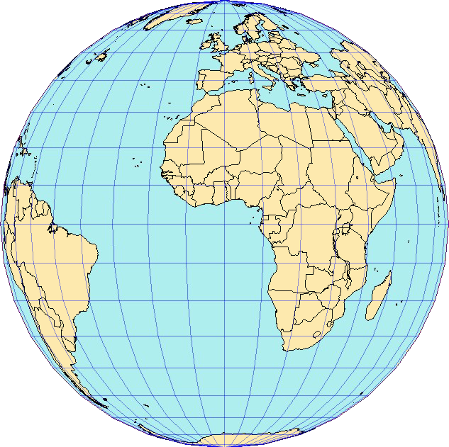

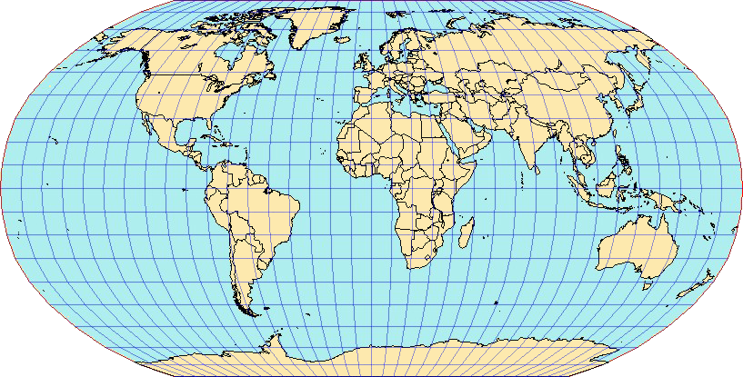Other projections minimize overall distortion but don’t preserve any of the four spatial properties of area, shape, distance, and direction. The Robinson projection, for example, is neither equal area nor conformal but is aesthetically pleasing and useful for general global-scale mapping.

### Universal Transverse Mercator Coordinate System

The Universal Transverse Mercator coordinate system (UTM) is a geographic coordinate system which is used to identify locations on earth in meters, as measured in the Northern Hemisphere going North and East from the intersection of the equator and a central meridian assigned to each of 60 longitudinal zones around the earth. UTM can be projected from the ellipsoid to a planar UTM zone using a transverse Mercator projection. Therefore, it is a conformal projection. Each zone is widest at the equator (covering 6 degrees) and narrower moving toward the poles. Zones north of the equator use the designation “N”.

### Projections in ArcGIS Pro

ArcGIS Pro reprojects data on the fly so any data you add to a map adopts the coordinate system definition of the first layer added. This means ArcGIS Pro can display data stored in one projection as if it were in another projection. The new projection is used for display and query purposes only. The actual data is not altered. As long as the first layer added has its coordinate system correctly defined, all other data that has correct coordinate system information reprojects on the fly to the coordinate system of the map.

## SPECIFYING MAP PROJECTIONS AND COORDINATES

* Change the map projection to UTM and the map units to metre. For a correct choice of the projection stripe, check in which UTM zone the data set is located.

### Calculating the UTM Zone

The *Calculate UTM Zone* tool calculates a UTM zone of each feature based on the centre point and stores this spatial reference string in a specified text field.

1. RIGHT-CLICK the *buildings* layer in the *Contents* pane and CLICK *Attribute Table* Open Table.
2. CLICK the *Add button* to create a new field. The *Fields View* is automatically opened.
3. In the Fields list view, set the following properties
   * Set the name *UTM_zone* for the new field. *Alias* can be defined the same.
   * Set the *Data Type* to the *Text* type.
   * Set thestring *Length* to 600. (This length is required for the *Calculate UTM Zone* tool)
4. CLICK on Save , which You find on the *Fields* tab in the *Manage Edits* group. The changes have now been applied to the attribute table of this layer.
5. Go to the *Analysis* tab to CLICK on *Tools* . The *Geoprocessing* pane will open.
6. Search for the *Calculate UTM Zone* tool and open it.
7. SELECT *buildings* as *Input Feature* and SELECT the new string field *UTM_zone* as *UTM Zone Field.*
8. CLICK Run to execute and write the calculated spatial reference strings.
9. View the calculated new field in the attribute table. You will see that the zone *32* has been identified as the correct UTM sector (with the latitude band *U*, which is one of the north (N) bands). This information will be used for the following step.

### Changing the Coordinate System in the Map Properties

1. In the *Contents* pane, RIGHT-CLICK the *Map* and CLICK *Properties*.
2. On the **Map Properties** dialog box, CLICK the *Coordinate Systems* tab.
3. CLICK to activate the *Current XY* WGS84 coordinate system.
4. Navigate on the *XY Coordinate Systems Available* list to *Projected Coordinate System > UTM > Europe > ETRS 1989 UTM Zone 32N*.
5. CLICK *OK*. The map features will be reprojected and redrawn to the UTM projection. The noticeable distortions are removed.
6. On the status bar, at the bottom of Your programme window, CLICK on the dropdown arrow next to the coordinates. CHOOSE *Meters* to view the mouse cursors location in customary UTM coordinates.

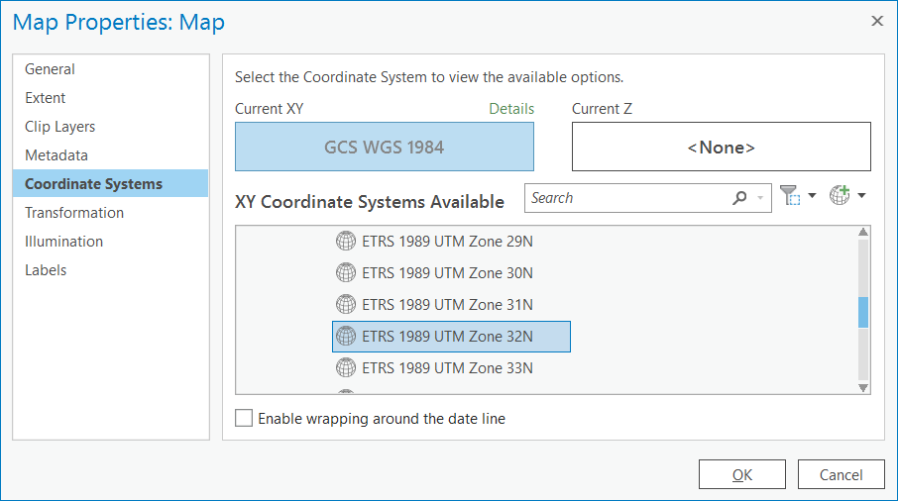

### Georeferencing a raster to a referenced layer

When you georeference your raster dataset, you define its location using map coordinates and assigning a coordinate system. Generally, you will georeference and align your raster dataset using existing spatial data (target data), such as a vector feature class, which includes the desired map coordinate system.

This assumes that there are visible features in your spatial data to match with the raster data such as building corners. The process involves identifying a series of ground control points (known x, y coordinates) that link locations on the raster dataset with locations in the spatially referenced data (target data). The control points are used to build a polynomial transformation that converts the raster dataset from its existing location to the spatially correct location. The connection between one control point on the raster dataset and the corresponding control point on the aligned target data is called a link. The number of links you need depends on the complexity of the polynomial transformation you plan to use to transform the raster dataset into map coordinates. However, adding more links will not necessarily yield a better transformation. If possible, you should spread out the links over the entire raster dataset rather than concentrating them in one area. Typically, having at least one link near each corner of the raster dataset and a few throughout the interior produces the best results.

Generally, the greater the overlap between the raster dataset and target data, the better the alignment results, because you’ll have more widely spaced points to georeference the raster dataset. For example, if your target data only occupies one quarter of the area of your raster dataset, the areas outside the overlap are not likely to be properly aligned. Keep in mind that your georeferenced data is only as accurate as the data to which it was aligned.

* The orthophoto georeferencing is spatially not very accurate. Align it to the buildings layer to improve the spatial accuracy.

1. Toggle on the visibility of the *orthophoto.tif* raster file.
2. In the Contents pane, RIGHT-CLICK the *buildings* layer (target layer; the dataset in the correct location) and CLICK *Zoom to Layer*.
3. In the Contents pane, CLICK the *orthophoto.tif* layer (source raster layer) you want to georeference.
4. To display the *Georeference* tab, CLICK the *Imagery* tab and then CLICK *Georeference* .

* The tools on the *Georeference* tab are split into several groups to help you use the correct tool in the proper phase of your georeferencing session.

1. In the *Prepare* group, CLICK *Set SRS* Set spatial reference system. The raster layer you are georeferencing is placed with the current map display.

* If your raster dataset already has a spatial reference, it will be automatically used as the coordinate system for the map and the georeferencing session. If your raster dataset does not have a spatial reference, the *Map Properties* dialog box will appear, and you can choose the coordinate system to set for the georeferencing session; the default spatial reference is the current coordinate system of the map.

1. In the *Contents* pane, turn off the visibility of any layer that you do not want to use as a reference dataset.
2. Use the navigation tools to zoom and pan closely onto a clearly visible building corner.
3. In the *Adjust* group, CLICK the *Add Control Points* tool Add Control Pointsto create control points. To add a control point, first CLICK a location on the orthophoto (the source layer), and then CLICK the same location on the building corner in the map (the target layer). The alignment is visibly updated.
4. Add more *Control Points* (6 to 10) distributed over the whole orthophoto.
5. CLICK the *Transformation* Button Transformation In the Adjust group, to SELECT *1st Order Polynomial*. This prepares an affine transformation.
6. CLICK the *Control Point Table* button Open Control Point Table to view your *Links*. You theoretically need a minimum of three control points. Delete any unwanted control points. I.e. delete the links with the highest *Residuals*.
7. If you're satisfied with the current alignment, stop entering control points.
8. In the *Save* group of the *Georeference* tab, CLICK *Save* to apply the georeferencing.
9. Leave the Georeferencing tool with the *Close Georeference* Button .

## ADDING TABLES

Tabular data can be added to ArcGIS Pro. Apart from Esri´s own file types You can add Text, ASCII, and comma-separated values (CSV) files, as well as Excel files. You can work with such tabular data in the same way as with the attribute table of other geodata features.

* A geocoded address table is to be imported into *ArcGIS Pro*. The coordinates are to be shown as points on the *Map* by creating a new point feature.
* Furthermore, a list of addresses is to be geocoded.

1. Add the geocoded table *Address_points.txt* to Your *Contents* from *Moodle* (for how to Add Data, see Lesson 1).
2. Open the tables by RIGHT-CLICKING on the table layer in the *Contents* pane and CLICKING *Open*.
3. View the attribute information of the tables. They will be used for the following tasks.

### Coordinate Tables to Points

1. On the *Map* tab, RIGHT-CLICK the stand-alone table Address_points.txt in the *Contents* pane, HOVER OVER Create Points from Table, and CLICK *XY Table To Point*. The *XY Table To Point* dialog box opens.
2. Specify the parameters, by choosing *Longitude* as *X Field* and *Latitude* *as Y Field*. Leave the *Coordinate System* as WGS 84.
3. CLICK *OK* to execute the tool and create the point feature layer.

* The source table must contain at least two numeric fields: one for the x-coordinate and one for the y-coordinate. A field for the z-coordinates that enables 3D geometry is optional. The values can represent any coordinate system and units such as latitude and longitude or meters. If the fields are not numeric, such as coordinate values in degrees, minutes, and seconds (for example, -120 13 58), the coordinates are converted and displayed as decimal degrees.

## GEOCODING

Finding places on a map is an integral part of a GIS. Geocoding is the process of transforming a description of a location, such as an address or a name of a place, to a location on the earth's surface. You can geocode by providing one location description at a time to zoom to a location on a map or convert an entire table that can be used for spatial analysis. Various types of locations can be used for geocoding.

* Several geoprocessing tools (i.e. geocoding) consume ArcGIS credits when they are run. These tools can be used in the same way as other geoprocessing tools. The only difference is that your user name must have privileges to use the given tool. You were given 10 consumer credits with your TUM login. This is enough for the following task, which should cost 4 consumer credits.

1. Add the address table *Housenumbers.txt* to Your *Contents* from *Moodle*. *Open* the Attribute table to see that these addresses do not feature coordinates.
2. On the *Map* tab, RIGHT-CLICK the stand-alone table *Housenumbers.txt* in the *Contents* pane and CLICK *Geocode Table* . The **Geocode Table** pane appears. It displays a list of steps to geocode your table.
3. CLICK *Start*. The guided workflow begins.
4. SELECT ArcGIS World Geocoding Service as *Input Locater* to Complete the *Step One: What locator are you using?* pane. Proceed with *Next*.

1. Complete the *About your table* step of the guided workflow. SELECT *More than one field* to indicate that the full addresses are spread over multiple data columns. Proceed with *Next*.
2. Complete the *Mapping the fields in your table* step of the guided workflow. For each of the fields in your data that you want to use in geocoding, find the corresponding locator field and choose the appropriate data field in the drop-down menu. Choose address relevant fields only. Do not choose the field *name* (otherwise the algorithm tries to geolocate the name).

* If you need to review the fields in your data that need to be geocoded, CLICK the *Attribute Table* button Attributes to view the table.

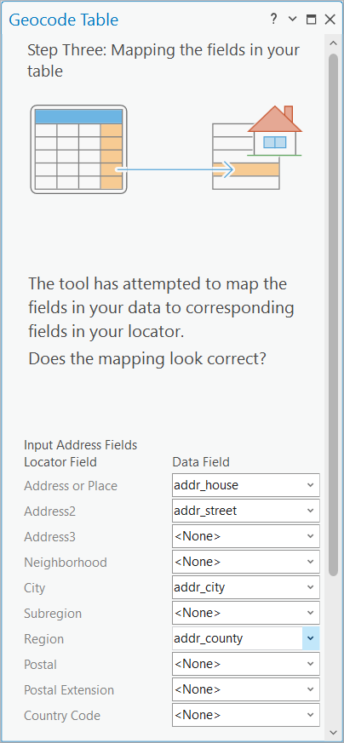

1. CLICK *Next*. In the *Output* step, an output location and name is selected automatically. SELECT *Address Location* as *Preferred Location Type*. Make sure that the *Add output to map* *after completion* check box is checked. CLICK *Next.*

* Address Location sets the geocoding so that the points represent the rooftop or parcel centroid for the address. The point displayed would be closest to the centre of the feature that represents the address. By contrast, you may be feeding the geocoding results into a routing application where you would want the points to be located on the side of the street for better routing, in which case Routing Location would be the better option. With this option, the point displayed is typically closer to the street and would be closer to where a vehicle would arrive at the location.

1. CHECK *Germany* and CLICK *Next* to complete the *Limit by Country* step of the guided workflow. This can lead to a better result and reduce the processing time. CLICK *Next.*
2. Leave the *Limit by* *Category* optional step untouched and CLICK *Finish*.
3. Review all inputs in the final step of the guided workflow, *Geocode Table*, and CLICK *Run*.
4. After execution and processing time review the Geocoding results in the Geocoding Completed window. CLICK No to decline the rematch process. The output is automatically added to the map. View the geocoded locations.

## MODIFYING FEATURES

On the *Edit* tab, in the *Features* group, the *Modify* Modify Features contains tools that edit finished features. When you enable map topology, tools that move, reshape, or edit vertices include modal tabs that allow you to edit topological edges and preserve coincident feature geometry.

### Snapping

On the *Edit* tab, in the *Snapping* group, *Snapping* List By Snappingcontains settings to manage how and when the pointer locks onto other features as you hover near them. These settings are also available on the status bar located at the bottom of the active map or scene.

Snapping enables you to accurately place or align features with other features. It can also be useful when measuring distances. Snap agents automatically snap the pointer to specific feature geometry, for example, to vertices, edges, or intersecting lines.

When you hover near a feature within the tolerance distance, textual feedback shows the active snap agents and the layer to which you are snapping. Optional settings include the XY tolerance in pixel or map units, the snap tip color, and snapping to unfinished sketch geometry.

* Turn on Snapping.

1. On the Edit tab, in the Snapping group, CLICK *Snapping* List By Snapping.
2. CLICK on the *Snapping* dropdown arrow and activate Vertex Snapping. The mouse pointer will now snap to the nearest vertex of a polyline or polygon.

* Each subsequent click on Snapping List By Snapping turns snapping on or off.

### Modify Feature Vertices

In the *Modify Features* pane, Edit Vertices Edit Vertices edits polyline and polygon feature vertices. You can add and delete vertices, and move them by dragging or specifying a distance or a coordinate location.

* One building polygon on the Heßstraße represents a planned building project. Move the vertices of the building polygon with the OBJECTID 954, so that it is in-line with the adjacent building rows.

* Extend the parallel outgoing underground line of the U2 on the Augustenstraße to the north in order to harmonise it with the general boundaries of the data.

1. Select the building polygon with the *OBJECTID 954* with the *Selecting By Attributes* tool (Lesson 1 knowledge).
2. CLICK the *building*s layer in the *Contents* pane to select it for editing.
3. On the *Edit* tab, in the *Manage Edits* group, CLICK the *Map Topology* Map Topology drop-down arrow and CLICK the *Map Topology* Map Topology to enable *map topology*.
4. On the *Edit* tab in the *Features* group, CLICK *Modify* Modify Features .The **Modify Features** pane appears.
5. EXPAND *Reshape* and CLICK Edit Vertices Edit Vertices. The tool opens in the pane. The vertices are highlighted on the map.
6. CLICK the vertex you want to move. The selection appears in a list in the (lower part) pane and highlights in the map. The editing toolbar appears with vertex tools.

1. DRAG the vertex using the pointer.

* To move the vertex by typing a distance or a coordinate location, RIGHT-CLICK the vertex. The context menu appears.

1. On the editing toolbar, CLICK Finish Finish or press the *F2 key* to apply your changes.

* If your edits break the topology graph, the message Edit operation failed Errorappears and your changes are cancelled.

### Reshaping and Adding Vertices

In the Modify Features pane, Reshape Reshape replaces segments of a feature with new geometry you create in the map where the first and last segments cross or touch the feature. Attribute values of the original feature are preserved.

* A shortly completed building project on the Theresienstraße is not represented in the building layer. Create new polygons and digitize the building outlines provided by a given construction plan. You must first georeference the construction plan.

1. Add the image *construction_plan.png* from Moodle.
2. RIGHT-CLICK the image on the *Contents* pane to *Zoom To Layer* . View the construction plan. It is constructed around the Theresienstraße 73.
3. To display the Georeference tab, CLICK the *Imagery* tab and then CLICK *Georeference* .
4. In the *Adjust* group, CLICK the *Add Control Points* tool Add Control Pointsto create control points. To add a control point, first CLICK a location on the construction plan (the source layer).
5. Zoom to the buildings Layer by *Zoom To Layer* . After closer zooming CLICK the same location on a building corner on the map (the target layer). The alignment is visibly updated.
6. Add one or two more *Control Points* distributed over the construction plan.
7. When finished, CLICK *Save* to apply the georeferencing.
8. Leave the Georeferencing tool with the *Close Georeference* Button .

* Now that the construction plan is referenced You can start editing the *buildings* layer. Here we want to remove a torn down building part by reshape a polygon.

1. Select the buildings layer on the Contents pane and Go to the *Edit* tab on the ribbon.
2. The buildings with the *OBJECTID 1901* and *1902* have been demolished for the new construction. Select these two buildings and delete them, i.e. by using the *DEL* keyboard short-cut, or by using the Delete on *Edit* tab, in the *Features* group.
3. An extension of the building *OBJECTID 1653* has been teared down. *Select* the polygon to *Reshape* the building polygon in the following steps.
4. Make the buildings layer transparent using the *Feature Layer* tab (see Lesson 2) in order to see both sources, the *buildings* layer and the underlying construction plan. You will have to activate *Edge Snapping* for this reshaping task (see 3.5.1).
5. On the *Edit* tab in the *Features* group, CLICK *Modify* Modify Features .The **Modify Features** pane appears.
6. EXPAND *Reshape* and CLICK *Reshape* Umformen. The tool opens in the pane.
7. Now, digitize along the new exterior wall in three points. The start- and endpoint on the current polygon contour. The middle point into the polygon´s inner surface. Therefore, CLICK the first two points to create a segment line wall building outline (see figure).
8. DOUBLE-CLICK the third point to apply your reshaping to this polygon.

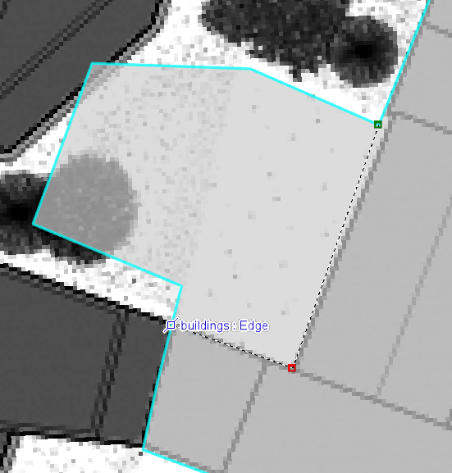

* Create new polygons by digitizing the outlines of the new buildings (the building footprints in the darker tone)

1. CLICK *Create* among the *Features.* The **Create Features**panewill open.
2. CLICK on the *buildings* Expansion dropdown arrow.
3. CLICK on the *Polygon* symbol Polygon to activate the polygon creating function.
4. Make new polygons by CLICKING in the given corners from the construction plan connecting to the existing building polygons and finish the digitizing by DOUBLE-CLICKING onto the last vertex.
5. Save the newly drawn polygons by CLICKING on *Save*  on the *Manage Edits* group of the Edit tab.

* Sometimes, the to be edited feature does not appear in the templates list on the *Create Features* pane. First, check if the visibility of the layer is toggled on, on the *Contents* pane. If it still doesn’t appear, then you need to create a new template. In this case, perform the following workflow:

1. CLICK *Create Features* (or *Manage Templates*)next to the *search* option in the *Create Features* pane.
2. CLICK on the *New* New Template expansion dropdown arrow.
3. CLICK on *Template…* to open **Template Properties**.
4. CLICK *General*(if not done already).
5. In the *Name* text box, type a name (i.e. *buildings)* for the new template.
6. In the *Description* text box, you can document the template with an optional description that you and your organization can search and find in the pane. In the *Tags* text box, the keyword for the geometry type is automatically generated. You can delete it or add additional tags. These are not needed for this task.
7. CLICK *OK.*
8. Close *Manage Templates* to go back to the *Create Features* pane. The intended layers of the template should appear in the list.

### Split a Feature

In the *Modify Features pane, Split* Split divides a line or a polygon feature into two or more features using a sketched line or a selection of features as input. The angular pitch of z-enabled segments is preserved and new vertices are assigned interpolated z-values. Attribute values from the original feature are copied to the new features.

* The State Museum of Egyptian Artand the University of Television and Film are currently represented by the same polygon feature. The task is to split this feature into two new polygons and update the attribute information.



Image taken from Wikipedia, 2019

1. Select the State Museum of Egyptian Artand the University of Television and Film polygon with the *OBJECTID 1859*.
2. On the *Edit* tab in the *Features* group, CLICK *Modify* Modify Features .
3. EXPAND *Divide* and CLICK *Split* Edit Vertices. The tool opens in the pane.
4. CLICK on the first vertex and then DOUBLE-CLICK on the second vertex to define a splitting line. The splitting is performed immediately.

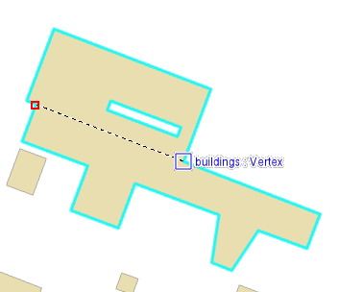

1. Update the *buildings* attribute table by editing the field *name* of both new polygons so that the names *State Museum of Egyptian Art* and *University of Television* *and Film* appear on the associated field column *name*. (The State Museum of Egyptian Art is the north and smaller building part.)

### Clipping a Feature

In the *Modify Features* pane, *Clip* Clip splits editable features that are visible and intersect other visible features. Features are clipped where they cross a specified buffer area. You can choose to keep or delete the features inside or outside the clip area, or split the target features and preserve both areas.

* Currently, the lawn area polygon intersects with the Alte Pinakothek building. Clear the lawn polygon part under the building by using the clipping tool.

1. Zoom to your *lawn* polygon and select it (this was created in Lesson 1).
2. On the *Edit* tab, in the Features group, CLICK *Modify* Modify Features.
3. Expand Divide and CLICK *Clip* Clip. The tool opens in the pane .
4. At the bottom of the pane, CLICK *Discard* Discard to delete the clipped features that fall inside the clipping area and preserve all others.
5. CLICK Select Select and select the feature that you want to use as the clipping feature (Alte Pinakothek).
6. Now change to Target Features, SELECT the lawn as the target feature.
7. CLICK *Clip*. The polygon part inside the clip area is deleted. Check by toggling the visibility of the layer *buildings*.

* Save all edits of this chapter by CLICKING under the Edit tab on Save .

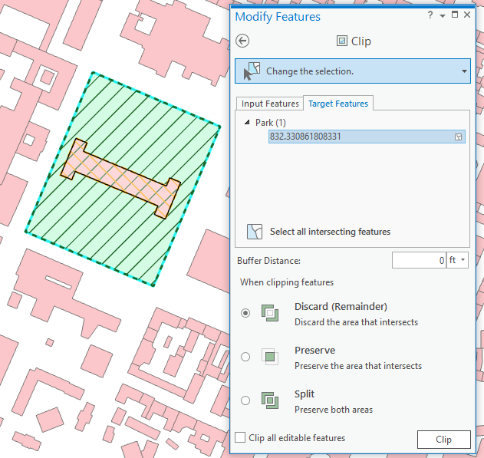

Contents

Lesson 3 – Georeferencing and Modifying Features 1

3.1 GENERAL INFORMATION ON COORDINATE SYSTEMS AND PROJECTIONS 1

3.1.1 WGS 84 1

3.1.2 Flattening the Earth 2

3.1.3 The Distortion Problem 2

3.1.4 Map Projections 2

3.1.5 Universal Transverse Mercator Coordinate System 4

3.1.6 Projections in ArcGIS Pro 4

3.2 SPECIFYING MAP PROJECTIONS AND COORDINATES 5

3.2.1 Calculating the UTM Zone 5

3.2.2 Changing the Coordinate System in the Map Properties 5

3.2.3 Georeferencing a raster to a referenced layer 6

3.3 ADDING TABLES 8

3.3.1 Coordinate Tables to Points 8

3.4 GEOCODING 9

3.5 MODIFYING FEATURES 11

3.5.1 Snapping 11

3.5.2 Modify Feature Vertices 12

3.5.3 Reshaping and Adding Vertices 13

3.5.4 Split a Feature 15

3.5.5 Clipping a Feature 17